Japan Analytical & Scientific Instruments Show 2015 (JASIS 2015) Calls for International Exhibitors
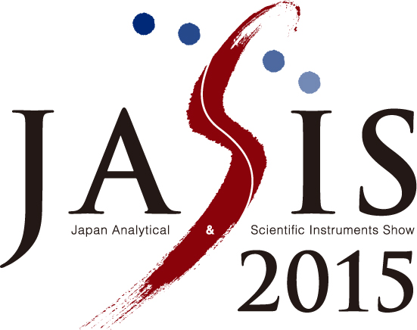
- Featuring a Special Exhibition Zone for Advanced Diagnostics Innovations -
JASIS 2015
TOKYO--(BUSINESS WIRE)-- The Japan Analytical Instruments Manufacturers' Association (JAIMA; 1-12-3 Kanda Nishiki-cho, Chiyoda-ku, Tokyo, 101-0054; President: Shigehiko Hattori, Chairman of the Board, Shimadzu Corporation) and the Japan Scientific Instruments Association (JSIA; 3-8-5 Nihonbashi-Honcho, Chuo-ku, Tokyo, 103-0023; President: Hideto Yazawa, Chairman, Dalton Co., Ltd.) are pleased to announce that they will jointly organize the Japan Analytical & Scientific Instruments Show 2015 (JASIS 2015), which is to be held on September 2-4, 2015 at Makuhari Messe, Chiba, Japan, and they are opened for applications from international exhibitors until April 13th. Application form and the detailed information can be found at the JASIS website (http://www.jasis.jp/en).
Under the theme of "Discover the Future," JASIS 2015 event will be a large-scale exhibition of analytical instruments and scientific equipment products from Japan and abroad, assembling an impressive array of the latest advances achieved in these types of products at a single venue. Last year, JASIS 2014 attracted a total of 23,794 visitors during 3 days, with 466 exhibitors and 1,399 booth spaces. “We expect JASIS 2015 to reach a scale of 500 exhibitors with 1,500 booth spaces, and to attract a total of 30,000 visitors,” says Masao Nomoto, the chairman of JASIS 2015 organizing committee. “Those figures make JASIS to be one of Asia’s largest exhibitions of analytical and scientific instruments.”
In addition to the main exhibition event, the show will also include seminars on both basic and applied fields, academic conferences, and the New Technology Seminar, where exhibitors can showcase their latest technical breakthroughs. First time this year, the show provides an affordable offer for foreign suppliers who look for a distributor in the Japanese market. The offer includes Seminar to Find Sales Channel, where the exhibitor can make a seminar for Japanese distributors to be videotaped and will be on-line at JASIS website for one year, an affordable poster exhibition package, and a special guidance by an experienced marketing consultant on how to get into the Japanese market.
Life science has been the area where JASIS has been concentrated on in the last few years. Like last two consecutive years, JASIS 2015 will again include a special exposition area devoted to life-science applications including drug discovery, pre-disease, and food science. The area, the Advanced Diagnostics Innovation Zone, is positioned to tackle themes related to the diagnostics market in the near future. The zone will serve as the main platform for providing new business opportunities for all relevant industries and for global expansion.
JASIS 2015 is a must exhibit event in Asia for those who seeks for a market for analytical and scientific instruments in the area.

Contacts
JASIS 2015 Secretariat (JAIMA)
Mr. Yuji Hamazaki/Ms. Mayuko Ogawa, +81-3-3292-0642
webmaster@jaima.or.jp
http://www.jasis.jp/en/

